Internet of Things (IoT)

Intelligent and Digital Manufacturing

Badman, Derek

Patrick Maynard

Linda George

Noor Pola

2024

Contents

Executive Summary 2

1. Introduction 2
2. What is Internet of Things (IoT) 2
3. Experiment 2
   1. Premise 2
   2. Breakdown 2
   3. Outcome 2
4. Our Findings/Experience 2
5. Applications in the industry 2
6. Security Concerns and implementation 3
7. Next Steps for IoT 3

7.1 Security and Regulation 3

7.2 Trends in Technology 3

7.3 Market Growth 4

1. Conclusion 4

References 4

Appendix 5

1. Arduino MKRWfFi1010V2.0 Schematic 5

2. Raw Experiment Data 6

3. Arduino Code 8

# Executive Summary

# Introduction

# What is Internet of Things (IoT)

# Experiment

## Premise

## Breakdown

## Outcome

# Our Findings/Experience

# Applications in the industry

# Security Concerns and implementation

# Next Steps for IoT

Within the next five to ten years, Internet of Things is expected to undergo rapid growth to support an increased user interface. In order to succeed in developing a technology that will continue to make societal impacts and leave a lasting footprint in technological history. Internet of Things will need to focus on the following areas of development:

## 7.1 Security and Regulation

As internet crime increasingly continues to rise (125% in 2021 compared to 2020), cybersecurity and the regulation of same is an important focus for the developers of Internet of Things technology.

Internet of Things developers are expected to incorporate practical cybersecurity measures such as encryption, certificate-based authentication, and security standardization across platforms.

Developers of Internet of Things will be challenged by ensuring the technology and security measures conform to privacy legislation across global jurisdictions. In Canada, developers must ensure they comply with the federal Personal Information Protection and Electronic Documents Act.

## 7.2 Trends in Technology

A large focus of developers of Internet of Things throughout the development of the technology will be to keep up with ever-changing trends and societal progression. As society evolves, technology is expected to become evermore integrated into the consumer’s daily life.

Internet of Things is expected to expand to futuristic society that incorporates technology such as smart cities, wearables, and transportation. As such, developers are expected to focus much of their attention to ensure the Internet of Things technology is advanced in a way that can support such a change in global societies.

## 7.3 Market Growth

It is important for developers of Internet of Things technology to be aware of the differing market needs and industry of the many users of the technology. For example, the needs and wants of a user of wearable technology will differ greatly from a user of medical technology.

Developers will have to implement practical approaches and apply revolutionary as well as precedent techniques to ensure that different industries are accommodated. This will ensure a smooth transition to the use of Internet of Things technology.

Despite the many challenges that the developers of Internet of Things technology will face in the coming years, there is no doubt that Internet of Things will have a significant impact on society as a whole.

# Conclusion

# References

Bhattacharayya, R. et al. (2010). Low-cost, ubiquitous RFID-tag-antenna-based sensing. Proceedings of the IEEE. 98 (10). 1593-1600.

L. D. Xu, W. He and S. Li, "Internet of Things in Industries: A Survey," in IEEE Transactions on Industrial Informatics, vol. 10, no. 4, pp. 2233-2243, Nov. 2014, doi: 10.1109/TII.2014.2300753.

Li, S., Xu, L.D. & Zhao, S. The internet of things: a survey. Inf Syst Front 17, 243–259 (2015). https://doi.org/10.1007/s10796-014-9492-7

Madakam, S. , Ramaswamy, R. and Tripathi, S. (2015) Internet of Things (IoT): A Literature Review. Journal of Computer and Communications, 3, 164-173. doi: 10.4236/jcc.2015.35021. LaFlamme, R., & LaFlamme, R. (2023, October 30). *What’s next for the Internet of Things* Auvik. https://www.auvik.com/franklyit/blog/future-of-it/

Imber, D. (2024, February 21). The Latest Cyber Crime Statistics (updated February 2024) AAG IT Support. *AAG IT Services*. https://aag-it.com/the-latest-cyber-crime-statistics#:~:text=Cyber%20Crime%20Overview,businesses%20and%20individuals%20in%2 2022.

Legislative Services Branch. (2019, June 21). *Consolidated federal laws of Canada, Personal Information Protection and Electronic Documents Act*. https://laws-lois.justice.gc.ca/eng/acts p-8.6FullText.html#:~:text=An%20Act%20to%20support%20and,the%20Statutory%20Instrums20Act%20and

# Appendix

## 1. Arduino MKRWfFi1010V2.0 Schematic

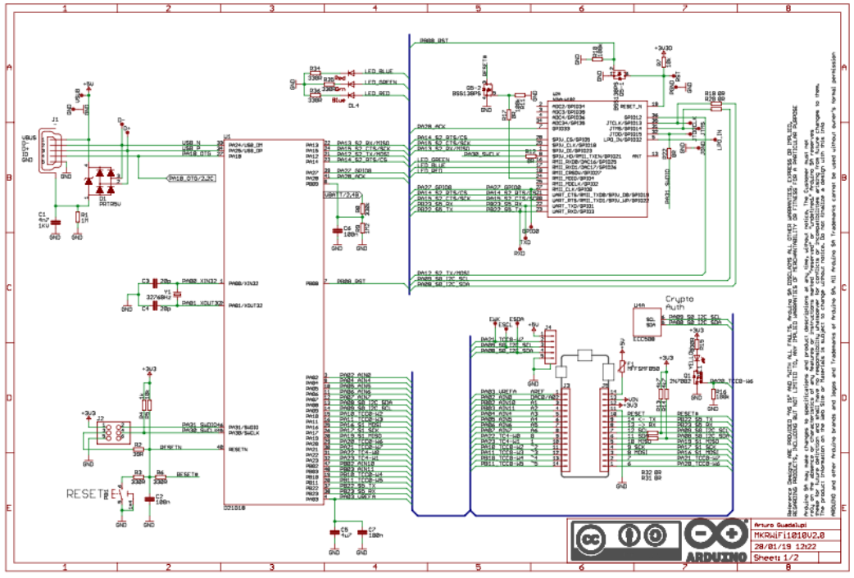

## 2. Raw Experiment DataScreenshot 2024-03-03 at 11.10.02 AM.png

| **Time** | **Humidity** | **Temperature** |
| --- | --- | --- |
| 2024-02-23T00:15:07.154216356Z | 870.5 | 640.2999877929690 |
| 2024-02-23T00:15:27.16232095Z | 870.5999755859380 | 640.2000122070310 |
| 2024-02-23T00:16:07.189374697Z | 870.7000122070310 | 640.0999755859380 |
| 2024-02-23T00:16:27.197187536Z | 870.5999755859380 | 640.2000122070310 |
| 2024-02-23T00:17:27.372441351Z | 870.5 | 640.0999755859380 |
| 2024-02-23T00:17:47.223373163Z | 870.7000122070310 | 640.2000122070310 |
| 2024-02-23T00:18:27.23820977Z | 870.5999755859380 | 640 |
| 2024-02-23T00:18:47.65518405Z | 870.7000122070310 | 640.0999755859380 |
| 2024-02-23T00:19:07.293200722Z | 870.5999755859380 | 640 |
| 2024-02-23T00:19:27.298825208Z | 870.7000122070310 | 640.0999755859380 |
| 2024-02-23T00:19:47.306921705Z | 870.5999755859380 | 640 |
| 2024-02-23T00:20:07.315180638Z | 870.7000122070310 | 640.0999755859380 |
| 2024-02-23T00:21:07.741060404Z | 871.0999755859380 | 640.5999755859380 |
| 2024-02-23T00:21:27.371427129Z | 845.5 | 640.5 |
| 2024-02-23T00:21:47.449481926Z | 0 | 0 |
| 2024-02-23T00:23:11.921398119Z | 0 | 0 |
| 2024-02-23T00:25:34.866884658Z | 0 | 0 |
| 2024-02-23T00:25:49.308228086Z | 819.7999877929690 | 666.2000122070310 |
| 2024-02-23T00:27:03.422177734Z | 819.7999877929690 | 665.7999877929690 |
| 2024-02-23T00:27:19.556141981Z | 33.29999923706060 | 665.7999877929690 |
| 2024-02-23T00:27:39.562747806Z | 33.5 | 25.5 |
| 2024-02-23T00:27:59.575034211Z | 34 | 25.399999618530300 |
| 2024-02-23T00:28:19.583631639Z | 33.5 | 25.5 |
| 2024-02-23T00:29:39.617700076Z | 33.599998474121100 | 25.399999618530300 |
| 2024-02-23T00:29:59.623955856Z | 33.70000076293950 | 25.299999237060500 |
| 2024-02-23T00:30:39.960013182Z | 33.79999923706060 | 25.200000762939500 |
| 2024-02-23T00:30:59.661877726Z | 33.900001525878900 | 25.100000381469700 |
| 2024-02-23T00:31:39.685076624Z | 34 | 25.200000762939500 |
| 2024-02-23T00:31:59.701111112Z | 86.5999984741211 | 25.100000381469700 |
| 2024-02-23T00:32:19.903859517Z | 81.30000305175780 | 26 |
| 2024-02-23T00:32:39.715065425Z | 60.20000076293950 | 26.200000762939500 |
| 2024-02-23T00:32:59.728030558Z | 38.79999923706060 | 25.799999237060500 |
| 2024-02-23T00:33:19.75402825Z | 36.79999923706060 | 25.5 |
| 2024-02-23T00:33:40.191138091Z | 36.29999923706060 | 25.399999618530300 |
| 2024-02-23T00:33:59.768802624Z | 36 | 25.200000762939500 |
| 2024-02-23T00:34:19.785873899Z | 35.79999923706060 | 26 |
| 2024-02-23T00:34:39.792169472Z | 35.70000076293950 | 27.799999237060500 |
| 2024-02-23T00:34:59.801103872Z | 35.599998474121100 | 25.799999237060500 |
| 2024-02-23T00:35:20.131639357Z | 71.80000305175780 | 25.700000762939500 |
| 2024-02-23T00:35:39.81817694Z | 95 | 25.5 |
| 2024-02-23T00:35:59.847205574Z | 58.5 | 25.299999237060500 |
| 2024-02-23T00:36:19.842703549Z | 39.5 | 25.200000762939500 |
| 2024-02-23T00:36:40.004774028Z | 37.099998474121100 | 25.100000381469700 |
| 2024-02-23T00:36:59.862867658Z | 36.400001525878900 | 25.200000762939500 |
| 2024-02-23T00:37:19.872705943Z | 36.099998474121100 | 25.100000381469700 |
| 2024-02-23T00:37:39.883085759Z | 36 | 25 |
| 2024-02-23T00:37:59.908612733Z | 35.79999923706060 | 25.100000381469700 |
| 2024-02-23T00:38:20.357643565Z | 35.599998474121100 | 24.899999618530300 |
| 2024-02-23T00:38:39.913532292Z | 35.5 | 25.200000762939500 |

## 3. Arduino Code

Paste Raw Code here***